Second Report of the MA Global Modelling Group

San Jose, Costa Rica 3- 07.03.2003

Report Prepared By:

Joseph Alcamo and Michael Märker
Center for Environmental Systems Research (CESR), University of Kassel

Participants

Joseph Alcamo (CESR), Jackie Alder (UBC), Bas Eickhout (RIVM), Michael Märker (CESR), Toshihiko Masui, Yasuaki Hijioka (Kyoto University), Brian O’Neill (IIASA), Mark Rosegrant (IFPRI), Hideo Harasawa (NIES), Detlef van Vuuren (RIVM), Garry Peterson (Uni Wisconsin), Gerhard Petschel-Held (PIK), Craig Doug (USGS),

Presentations in Costa Rica

Preliminary results from the first round global modeling exercise (minus biodiversity modeling) was presented. The models participating in this exercise are sketched out in Figure 1.

A sampling of results from the first round model calculations are given in the Power Point Presentation available on the MA Intranet (URL: www.millenniumassessment.org/intranet/ go to: documents/Scenarios/Global_Modeling_Group/sanjose-model-overview28-02-03.ppt)

Some of the comparisons between models were useful in identifying inconsistent results between two of the models. The cause of the differences were already identified in San Jose and will be harmonized during the second round of model calculations (between the San Jose meeting in March, 2003 and Prague meeting in October, 2003). Some of the causes were:
- Different reporting regions (AIM emissions)
- Different output parameters (S; SO₂; N, NO₂)
- Different climate data (AIM; WaterGAP)
- Different starting points for modeling (1995; 2000)
- Population and GDP slightly different for 1995
- Summing up of indicators according to reporting regions
- Slightly different assumptions for water use intensity and water use efficiency

Model results were basically consistent with the storylines up to now, but differences between scenarios were not large. Therefore it is important to either sharpen the storylines or change the drivers of the scenarios.

A priority for the second round of calculations is to link the output and input of the models:
- IMPACT will provide crop production data for IMAGE 2
- IMACT will provide fish consumption data for EcoSim and irrigated area to WaterGAP.
- WaterGAP will provide irrigation water availability for IMPACT (after WaterGAP is run with irrigated area from IMPACT).
- IMAGE 2 will provide climate data, electricity, livestock data for WaterGAP.
- IMAGE 2 will provide cropland area and technological change information for IMPACT.
- AIM will provide climate downscaling matrices to IMAGE.

Also of note, the AIM team is developing a world “Ecosystem” model with explicit links between ecological services and human well being.

The EcoSim model will be implemented in the coming weeks/months. Results will be available for the Prague meeting in October.

It was also decided that biodiversity modeling should be integrated to the maximum extent possible in the rest of the global modeling exercise. Ideas on how to do this were presented by J. Alcamo to the Plenary at the end of the meeting (see PowerPoint Presentation on the MA Intranet (URL: www.millenniumassessment.org/intranet/ go to: documents/Scenarios/ Global_Modeling_Group/sanjose-modelers-report.ppt)

Drivers for Second Round Calculations

Population Assumptions
Brian O’Neill and IIASA will generate new population scenarios based on the temporaöl patterns agreed upon in San Jose (Figure 2.a), and assumptions for fertility and other demographic factors consistent with the storylines (see Table 1).

Economic Growth Rate Assumptions
It was decided to adopt a new set of economic growth drivers. The basic principles of the new drivers will be:
1. Adopt the basic global temporal patterns consistent with the storylines shown in Figure 2b.
2. Maintain the relative differences between regions as noted in the SRES scenarios.
3. Reduce the very high growth rates in selected regions of the SRES scenarios.

Deltef van Vuuren, Mark Rosegrant, with Prabhu Pingali will develop economic assumptions consistent with the above, and will especially “shave off” the very high growth rates.

Model Output for Second Round Calculations

Base Year: 1995/2000

Other Reporting Years : 2020, 2050, 2100 (optional)

Reporting Regions : Sub-Saharan Africa, MENA (Middle East and North Africa), OECD, FSU (not including Eastern Europe), Latin America, Asia.
Modelers should also provide selected information on global/continental grid where available. Michael Märker will post a list of countries that belong to these regions.

In order to conform with the concepts used in the MA, the models will be used to compute the indicators shown in Table 2.

Action Points

When | What | Who
25 April | Demographic drivers to CESR (Kassel) | O’Neill
25 April | Economic drivers to CESR | van Vuuren, Rosegrant, Pengali
28 April | CESR posts demographic and economic drivers on MA Website. | Märker
28 April | CESR will post table that lists the countries that belong to the various reporting regions. | Märker/Alcamo
5 May | Develop harmonized assumptions for technological parameters (energy efficiency improvements, water efficiency improvements, etc.) post on MA website | van Vuuren, Märker/Alcamo  (in consulation with IMPACT & AIM teams)
16 May | For ecosystem services that can be computed by two or more models, CESR will propose that specific models should be used for “reference calculations”. | Märker/Alcamo
16 May | Propose framework for uncertainty analysis | Alcamo
1 June | Agree on framework for uncertainty analysis | All modeling teams
Early July | Meeting of sub-group of modeling team in Giessen, Germany. Purpose: To review model results and discuss the implementation of biodiversity calculations. | At least Alcamo/Märker,  van Vuuren
8 August | Complete uncertainty analysis and send to CESR | All modeling teams
8 August | Complete modeling runs and send to CESR so that they can be compiled and presented in Rome (see next item) | All modeling teams
25-27 August (tentative) | Meeting in Rome to evaluate model results, revise storylines, and communicate main messages of model calculations to authors of Chapters 6, 7, 8, 9, 10, 11, 12.
19 September | Final model calculations (if necessary) to CESR | All modeling teams
19 September –  12 October | Writing of various chapters that include scenario results. | Lead authors previously assigned by MA
13-17 October | MA meeting, Prague. Review text.
18 October –  15 December | Revise chapters. Produce draft for review.

Table 1: List of model drivers agreed upon at San Jose scenarios working group meeting (notes from Detlef van Vuuren)
 | EconOpt | Technogarden | Fortress | Local Learning
Demography  Population growth | G:Medium-low | G:Medium-low | G: High | G: Somewhat lower than fortress
Fertility | D: Low  I: Medium | D: Low  I: Low | D: Rel. high  I: High | Start from Fortress world – but diverge by 2010
Mortality | D: Low  I: Medium-low | D: Low  I: Low | D: Medium  I: Medium | Start from Fortress world – but diverge by 2010
Migration | Moderate – high, but decreasing | Moderate | Low.  High migration among D-countries | Low but might be increasing
Urbanization (change) | High | High | ? | Low
Comments |  |  | Possible crashes outside fortress?  Sub-story in storyline?
Economy
Income | High | Somewhat lower than EconOpt. Starting to catch up | I: Medium  D:Low | Starts like fortress and than improves
Income distribution | Medium improving | Similar as EconOpt. | Massive inequality – even within the fortress | Starts like fortress and than improves
Economic structure
(industry/services etc).
Rate of investment | High in human and physical | High in physical, human, natural | I: Medium  D: Low | Medium going towards high (in social)
 | EconOpt | Technogarden | Fortress | Local Learning
 | Medium = current rates
Technology
Rate of technology development | Medium-High | Medium moves to higher | Kind of lowish | Medium-low to medium (increasing)
Rate of env. technology development | Medium | High | Low but high for high income countries local env. problems | Medium
Irrigation efficiency | Medium-High | Medium moves to higher | I: low  D : low could become medium in long-term | Starts medium-low, increasingly medium to high
Yield improvement | Medium-High | I: organic farming .... thus low  D: Medium to high | I: low  D : low | I: Medium goes lower (organic farming)  D: Starts medium-low, increasingly medium
Impr. of water use efficiency | Medium | High | Low but high for high income countries local env. problems | Medium  (2015 divergence from)
Impr. energy efficiency | Medium | High | Low | Medium
Agriculture
Food preferences | High meat | Medium meat | I: High meat  D: low meat | low meat
Irigated areas | Moderate to high expansion of irrigated areas | I: No expansion  D: some expansion | I: Expansion inside to Fortress  D: Down but in long term up again | No expansion
Trade policy | Full liberalization | Full liberalization | Increasing protection | Current levels of protection but might be decreasing later on.
Lifestyle/human behaviour/structural change | Non-resource conserving | Resource conserving | I: ?  D: Non-resource conserving | Resource conserving
Environment
 | EconOpt | Technogarden | Fortress | Local Learning
Level of control of air pollution (local/region) | Kusnetz (control mainly for health reasons) | More reduction than Kusnetz | I: As EconOpt.  D: low | Medium but impr. where it is really bad
Level of control of air pollution (global) | No control – not much control | Substantial control | No control | Starts as Fortress – improves latter
Level of control of water pollution | Medium | High | I: Medium  D: Low | Starts as Fortress – improves latter

G: Global
D: Developing
I: Industrialized

Table 2: Proposed global modeling output
MA Ecosystem Service | Indicator | Model used to calculate indicator
Provisioning Services

Food | total meat, fish and grain production; consumption; trade, crop area | IMPACT
Food | potential grain production (optional), crop area (optional) | IMAGE
Food | potential grain production (Asia) (optional) | AIM
Food | fish production | EcoSim
Fiber | timber production per area, type of wood | IIASA forest model *
Fuelwood | biofuel supply (select one or two representative crops) | IMAGE, AIM
Fresh water | Annual renewable water resources, water withdrawals and consumption | WaterGap
Fresh water | Annual renewable water resources, water withdrawals and consumption (Asia) | AIM

Regulating services

Air quality constituents | Sulphur and NOx emissions | AIM, IMAGE
Climate regulation | Net carbon flux | IMAGE
Erosion | Erosion risk | IMAGE

Supporting Services

Primary production | Primary production | IMAGE, AIM
Primary production | Areal impact of human infrastructure | GLOBIO?: *
Human Well-being (not ecosystem services)

 | Percentage of children malnourished | IMPACT
 | Water stress | WaterGAP, AIM

Fig. 1 Structure of modeling exercise and flow of information for first round calculations

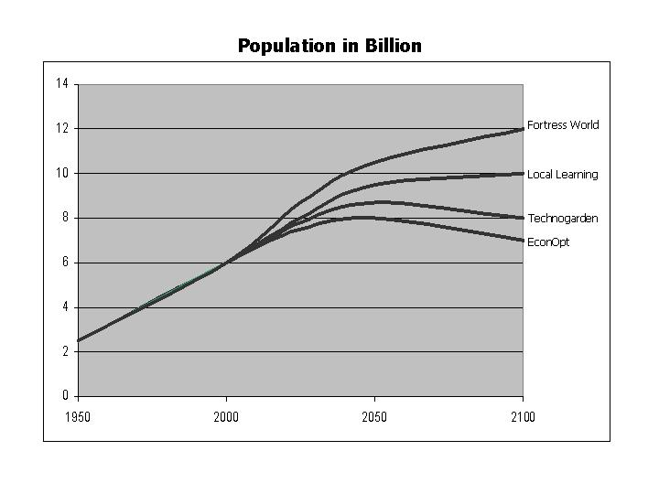
Figure 2a. Proposed temporal pathways of economic and demographic drivers for second round calculations (Population).

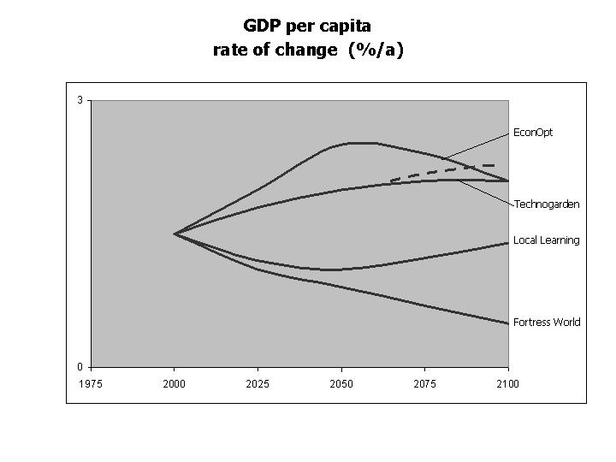
Figure 2b. Proposed temporal pathways of economic and demographic drivers for second round calculations (GDP per capita rate of change).
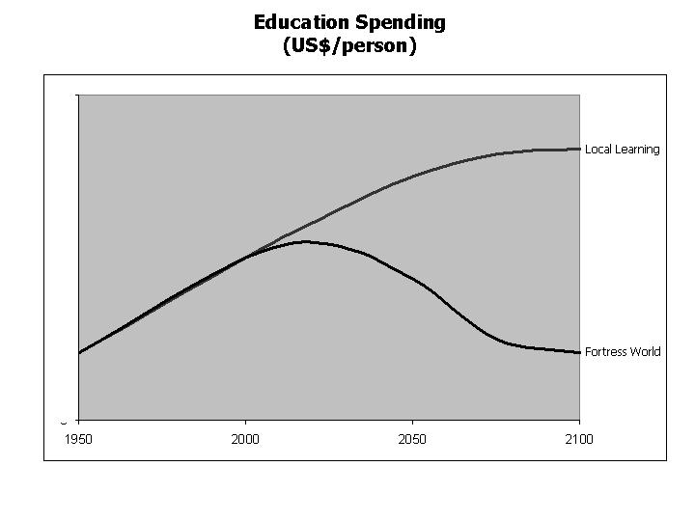
Figure 2c. Proposed temporal pathways of economic and demographic drivers for second round calculations (Education spending). These assumptions were used as a basis for selecting different pathways of GDP/cap (Fig 2b) for the Local Learning and Fortress scenarios.
Modeling Group contact addresses:

Joseph Alcamo, Center for Environmental Systems Research, University of Kassel, Kurt-Wolters-Str. 4, 34125 Kassel, Germany; Email: alcamo@usf.uni-kassel.de

Jackie Alder, UBC Fisheries Centre 2204 Main Mall, Vancouver BC, Canada V6T124; Email: j.alder@fisheries.ubc.ca

Villy Christensen, UBC Fisheries Centre 2204 Main Mall, Vancouver BC, Canada V6T124; Email: v.christensen@fisheries.ubc.ca

Bas Eickhout, RIVM; PO BOX 1; 3720BA Bilthoven, The Nederlands, Email: bas.eickhout@rivm.nl

Hideo Harasawa, National Institute for Environmental Studies (NIES),16-2 Onogawa, Tsukuba, 305-8506, Japan, Email:harasawa@nies.go.jp

Michael Märker, Center for Environmental Systems Research, University of Kassel, Kurt-Wolters-Str. 4, 34125 Kassel, Germany; Email: maerker@usf.uni.kassel.de

Toshihiko Masui, National Institute for Environmental Studies (NIES),16-2 Onogawa, Tsukuba, 305-8506, Japan, Email: masui@nies.go.jp

Yuzuru Matsuoka; Environmental Engineering, Kyoto University, 606-8501 Kyoto, Japan. Email: matsuoka@envhost.env.kyoto-u.ac.jp

Nebojsa Nakicenovic, IIASA, Schlossplatz 1, A-2361 Laxenburg, Austria, Email: naki@iiasa.ac.at

Brian O’ Neill, IIASA, Schlossplatz 1, A-2361 Laxenburg, Austria, Email: oneill@iiasa.ac.at

Garry Peterson, University of Wisconsin, Madison. 680 North Park Street Madison, WI 53706 United States; Email: gdpeterson@facstaff.wisc.edu

Gerhard Petschel-Held, Potsdam Institute for Climate Impact Research. P.O. BOX 60 12 03 D-14412 Potsdam, Germany; Email: gerhard@pik-potsdam.de

Mark Rosegrant, IFPRI; 2033 K. <Street, NW, Washington, DC20006, USA, Email: m.rosegrant@cgiar.org

Kiyoshi Takahashi, National Institute for Environmental Studies (NIES); 16-2 Onogawa, Tsukuba, 305-8506, Japan; Email: ktakaha@nies.go.jp

Detlef van Vuuren, RIVM; POBOX 1; 3720BA Bilthoven, The Nederlands, Email: detlef.van.vuuren@rivn.nl

Tianxiang Yue, IGSNRR, Building 917, Daun, Anwai, 100101 Beijing, China, Email: yue@lreis.ac.cn

